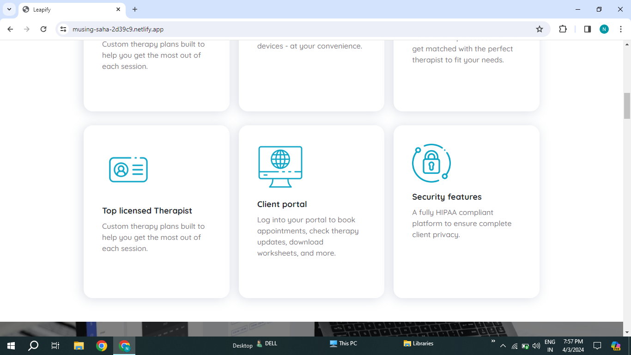

1.Licensed spelling mistake it should be Capital

2.Portal spelling should be capital.

3.(, and ) are grammertical mistake.

4.Features spelling should be Capital.